**Fundraising Blueprint**

**Homework Worksheets**

*Complete these worksheets before the event starts.*

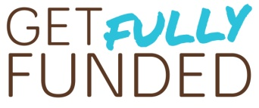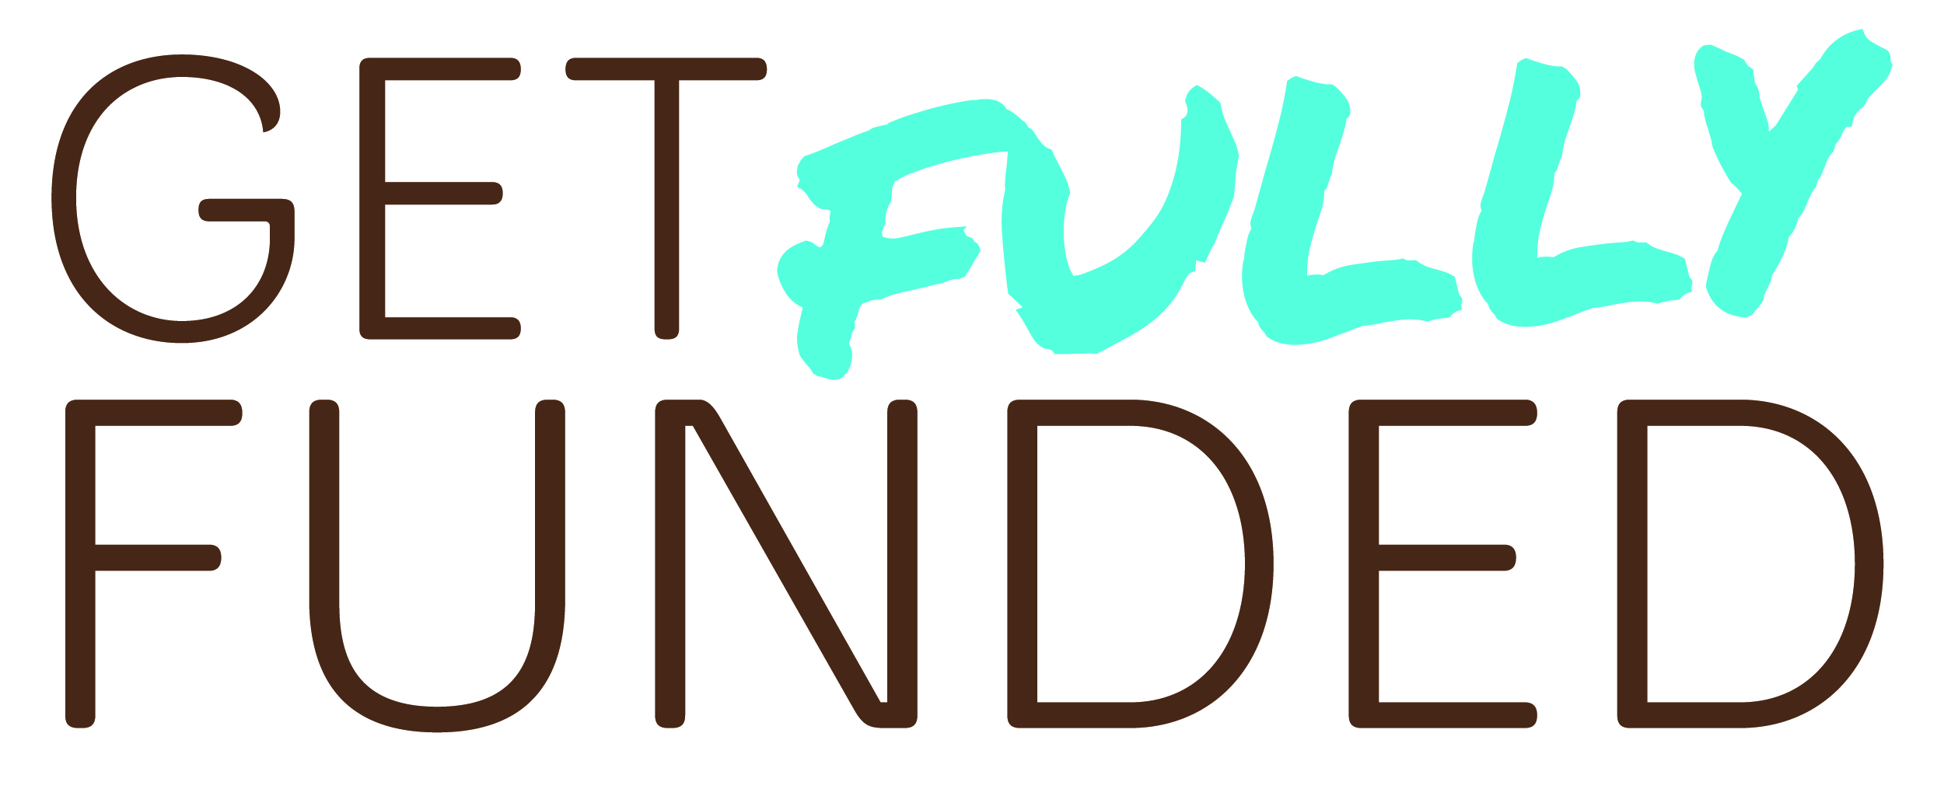State of My NonprofitWorksheet

|  |  |  |  |
| --- | --- | --- | --- |
|  | **Where I was Jan 2022** | **Where I am Jan 2023** | **What I want Jan 2024** |
| Revenue |  |  |  |
| Number of active donors |  |  |  |
| Number of monthly donors |  |  |  |
| Size of email list |  |  |  |
| Quality/Success of events |  |  |  |
| Revenue from grants |  |  |  |
| Board engagement |  |  |  |
| Community awareness |  |  |  |
| Staff size |  |  |  |
| Anything else |  |  |  |

**Key Measurements Worksheet**

Use this worksheet to gather key numbers for your fundraising efforts. Use the back if you need more room to write.

1. What’s the size of your donor family currently?
   1. Number of active donors (people who’ve given in the past 12 months)
   2. Number of new donors in the past 12 months
   3. Number of nongivers on your mailing list
2. How many of your family stuck with you?
   1. Number of donors who gave in 2021
   2. Number of those same donors who gave again in 2022
   3. Retention rate:

(Divide 2021 number/2022 number, and express as a percentage; your donor software may calculate this for you)

1. What does your fundraising pie look like?
   1. How much money did you raise in 2022?
   2. What were the main sources? (grants, events, monthly giving, etc.)
   3. If you made a pie chart to represent your fundraising, what would it look like?
2. How much did your donors love you?
   1. Overall, what was your average gift size?

(Divide your total money raised by the number of gifts)

* 1. Who gave the 10 largest gifts in 2022? How much were they?

1. Did your Board show the love in 2022?
   1. What was the total giving from your Board in 2022?
   2. What percentage of your total giving came from your Board?
   3. Did you have 100% Board giving? (Did every member of your Board give money?) _____