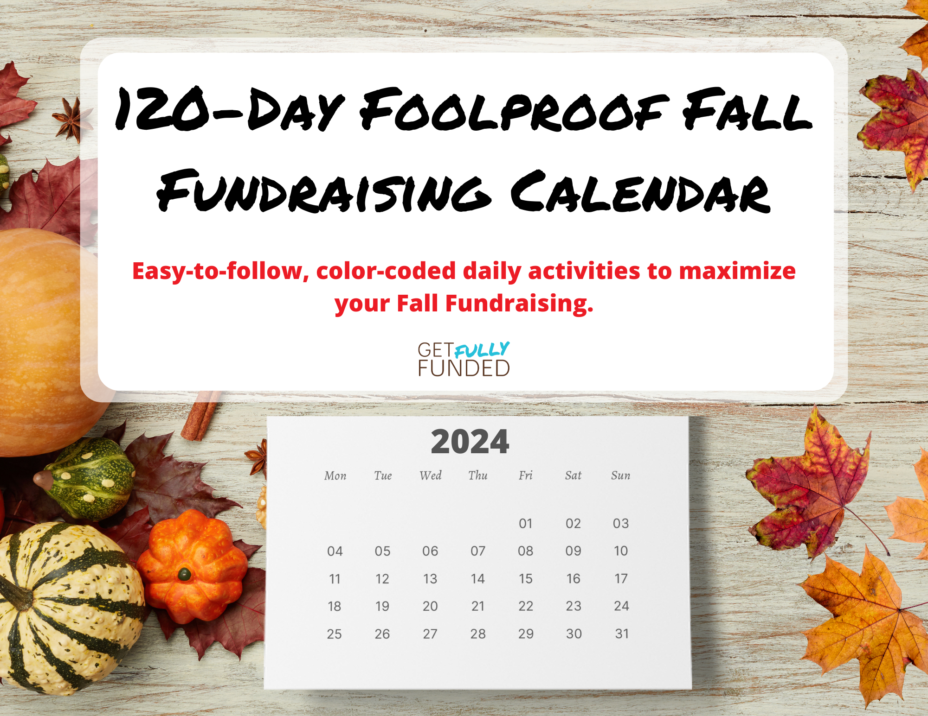Add New Cover

Super Fabulous resource ahead!

Hey my friend,

Here’s my **120-Day Foolproof Fall Fundraising Calendar,** freshlyupdated for 2024**.**

This calendar has been used by hundreds of nonprofits to raise hundreds of thousands of dollars for their good cause during the final months of the year. And now it’s your turn to use it!

The calendar is laid out in daily activities to make it easy to follow, and color-coded so you can manage your Ask-to-Warm Touch ratio.

When you customize it for your nonprofit… well, the sky’s the limit!

Enjoy!

-Sandy

September 2024

Color code: pink = donor love green = asks yellow = marketing

|  |  |  |  |  |  |  |
| --- | --- | --- | --- | --- | --- | --- |
| Sunday | Monday | Tuesday | Wednesday | Thursday | Friday | Saturday |
| 1 | 2  *Labor Day (US)* | 3  Draft donor e-newsletter | 4  Update thank-you letters | 5  Organize your files and your office | 6  Plan evergreen social media content for the month (memes, stats, infographics, education, etc.) | 7 |
| 8 | 9  Post heartwarming story on Facebook | 10  Send donor e-newsletter | 11  Gather at least 6 good heartwarming stories to share | 12  Post new blog article | 13  Find a matching gift for Giving Tuesday and/or Fall appeal/campaign | 14 |
| 15 | 16  Post heartwarming story on Facebook | 17  Plan special warm touches (or gifts) for monthly and major donors for the rest of the year | 18  Plan special warm touches (or gifts) for Board members and volunteers for the rest of the year | 19  *Talk Like a Pirate Day* | 20  Test Donate button;  Evaluate if you need a separate donation page for Fall appeal /campaign | 21 |
| 22 | 23  Post heartwarming story on Facebook | 24  Plan Fall appeal/campaign | 25  Plan evergreen social media content for the next month (memes, stats, infographics, education, etc.) | 26  Plan $5 Fridays for the rest of the year | 27  Gather 8 more good stories to share | 28 |
| 29 | 30  Post heartwarming story on Facebook |  |  |  |  |  |

October 2024

Color code: pink = donor love green = asks yellow = marketing

|  |  |  |  |  |  |  |
| --- | --- | --- | --- | --- | --- | --- |
| Sunday | Monday | Tuesday | Wednesday | Thursday | Friday | Saturday |
|  |  | 1  Draft donor e-newsletter  Update thank-you letters | 2  Plan Giving Tuesday campaign, including what to ask for (project or program) | 3  *Rosh Hashanah*  Connect with top donors to thank them for their support this year | 4  *Rosh Hashanah*  Draft Fall appeal and thank-you letter  Host a $5 Friday on Facebook | 5  *National Do Something Nice Day (US)* |
| 6 | 7  Post heartwarming story on Facebook | 8  Script general thank-you video  Send donor e-newsletter/video blast | 9  Share your Fall plan with your Board; give them each 3 specific things to do to help | 10  Post new blog article | 11  Draft Giving Tuesday images | 12  *Yom Kippur* |
| 13 | 14  *Thanksgiving Day (Canada)*  Post heartwarming story on Facebook | 15 | 16  Send out Fall appeal, post on social media | 17  Shoot general thank-you video | 18  Draft Giving Tuesday text for emails and social media posts | 19 |
| 20 | 21  Post heartwarming story on Facebook  Write thank-you call script for top donors | 22  Gather a list of top donors to thank with personalized video | 23  Recruit Ambassadors to help promote Giving Tuesday | 24  Finalize Giving Tuesday images and language  Edit general thank-you video | 25  Gather list of lapsed donors to renew  Plan evergreen social media content for the next month (memes, stats, infographics, education, etc.) | 26 |
| 27 | 28  Post heartwarming story on Facebook | 29  Draft donor e-newsletter  Update thank-you letters | 30  Send personalized notes to lapsed donors inviting them to renew | 31  *Halloween*  Remind your Board how they can help with fundraising |  |  |

November 2024

Color code: pink = donor love green = asks yellow = marketing

|  |  |  |  |  |  |  |
| --- | --- | --- | --- | --- | --- | --- |
| Sunday | Monday | Tuesday | Wednesday | Thursday | Friday | Saturday |
|  |  |  |  |  | 1  Create Giving Tuesday giving page on website (or other tool) | 2 |
| 3  *“Fall Back” reminder for Daylight Savings Ending (US only)* | 4  Post heartwarming story on Facebook  Gather 4 more stories or updates to share | 5  Plan your holiday cards: design, order/print, prep the mailing list, etc. | 6  Finalize general thank-you video  Draft Giving Tuesday thank-you letter and load into system | 7  Post new blog article | 8  Call top donors to thank them for their support over the past year | 9 |
| 10 | 11  *Veterans Day (US)*  Post heartwarming story on Facebook  Plan evergreen social media content for the next month | 12  Send donor e-newsletter; include Giving Tuesday teaser | 13  *World Kindness Day*  Plan a signing day for Nov 21st to have all team and Board sign cards for major and monthly donors | 14  Confirm Ambassadors for Giving Tuesday  Update your email signature to include Giving Tuesday | 15  *National Philanthropy Day (US)*  Host a $5 Friday on Facebook | 16 |
| 17 | 18  Post heartwarming story on Facebook | 19  Send Giving Tuesday email teaser #1, post on social media | 20 | 21  Sign Holiday cards, address envelopes | 22  Write script for personalized thank-you videos (for top donors) | 23  *Family Volunteer Day* |
| 24 | 25  Schedule emails and posts for this week  Post heartwarming story on Facebook | 26  Send Giving Tuesday email teaser #2, post on social media | 27 | 28  *Thanksgiving Day (US)*  Send Thanksgiving greeting (US) with general thank-you video; also post on social media | 29  *Black Friday (US)*  Post Giving Tuesday image on social media | 30  *Small Business Saturday (US)*  Post Giving Tuesday reminder on social media |

December 2024

Color code: pink = donor love green = asks yellow = marketing

|  |  |  |  |  |  |  |
| --- | --- | --- | --- | --- | --- | --- |
| Sunday | Monday | Tuesday | Wednesday | Thursday | Friday | Saturday |
| 1  Post Giving Tuesday reminder on social media | 2  *Cyber Monday (US)*  Send Giving Tuesday email teaser #3, post on social media | 3  *Giving Tuesday (US)*  Follow the Giving Tuesday plan for posts and emails | 4  Send Giving Tuesday thank yous and follow up (email and social posts) | 5  Update thank-you letters  Draft donor e-newsletter | 6  Shoot personalized thank-you videos (for top donors)  Mail Holiday cards to donors and VIPS | 7 |
| 8 | 9  Post heartwarming story on Facebook  Load personalized thank-you videos to YouTube or Vimeo | 10  Send donor e-newsletter/video blast | 11  Plan and draft Last Chance fundraising campaign (emails and social media posts) | 12  Write email and subject line for personalized thank-you videos | 13  Host a $5 Friday on Facebook | 14 |
| 15 | 16  Post heartwarming story on Facebook | 17  Pitch a story to the local news media for the week of the 28th  Post new blog article | 18 | 19  Email personalized thank-you videos to top donors | 20  *National Ugly Sweater Day*  Schedule Last Chance email appeals | 21 |
| 22 | 23  Post heartwarming story on Facebook | 24  *Christmas Eve*  Text special donors your gratitude (if appropriate) | 25  *Christmas Day*  Send Christmas greeting email (if appropriate) | 26  *Boxing Day (Canada)*  *Hanukkah 12/6-1/2*  Send Last Chance email #1 | 27  Post heartwarming story on Facebook | 28  Post Last Chance appeal on social media  Send Last Chance email #2 |
| 29  Post heartwarming story on Facebook | 30  Send Last Chance email #3  Post Last Chance appeal on social media | 31  *New Year’s Eve*  Send Last Chance email #3  Post Last Chance appeal on social media |  |  |  |  |

Need more help?

There’s some amazing stuff here, right?

But I know you may need a little help applying these new ideas to your own situation. Maybe you have questions about specific fundraising strategies or want to be sure you’re doing it right or just want to see an example.

That’s where Fundraising TV comes in.

Fundraising TV is a library of mini courses that guide you step-by-step on how put a rock-solid, comprehensive fundraising program in place for your nonprofit. It’s delivered in bite-sized videos that you can watch on demand, with hundreds of templates, cheat sheets, and samples to shortcut implementation so you can start raising MORE money FASTER.

Got a question about Giving Tuesday?

Dear Sandy,

**We brought in an additional $10,000 in individual donations in our 1st year!**

Now in our second year, we used what we learned to improve our grant applications through storytelling and using core numbers, and have been awarded $66,126.

**If you follow the strategies and action items in Fundraising TV, you will recoup your investment within the first month and most likely surpass it**.

Cassandra Sage

Influence the Choice

Want to see an example of a great year-end email?

Need scripts for thanking donors during the holidays?

You’ll find all that and more inside Fundraising TV.

Check it out at <http://getfullyfunded.com/frtv/>.

